PROJECT REPORT

Name :
Vanisha Srivastava 25BCE11245
Ananya Singh 25BCE11248
Aparna Baghel 25BCE10363
Megha Guleria 25BCE10168
Branch : CSE (core)
Year : 2025-2029
Course Code : CHY1005
Date : 05-04-2026

Molecular Solubility Predictor using Machine Learning

Abstract
Predicting the solubility of chemical compounds is a crucial task in fields like pharmaceuticals, environmental science, and chemical engineering. This project presents a Molecular Solubility Predictor that estimates the aqueous solubility (LogS) of organic molecules using machine learning techniques. The system utilizes molecular data represented in SMILES format and applies data-driven approaches to simplify and accelerate solubility prediction. By reducing reliance on traditional laboratory experiments, this approach offers a faster and more cost-effective alternative.

Problem Statement
Many chemical compounds fail in real-world applications due to poor solubility, especially in drug development. Traditional experimental methods for determining solubility are:
- Time-consuming
- Expensive
- Resource-intensive
There is a need for a computational solution that can predict solubility efficiently and accurately.

Objective
The main objectives of this project are:
- To develop a system that predicts aqueous solubility (LogS)
- To use molecular structure data (SMILES) for prediction
- To implement a machine learning-based approach
- To reduce dependency on experimental methods

Methodology
The project follows a structured pipeline:
1. Dataset
- It is already stored in the database, if a compound not given in the database comes it raises error.
2. Data Source
- Dataset contains:
  - Compound ID
  - SMILES representation
  - LogS values
3. Code Workflow
import pandas as pd
import os
file_name = "dataset.csv"
if os.path.exists(file_name):
df = pd.read_csv(file_name)
print(f"Successfully loaded {len(df)} molecules from local dataset.")
else:
print(f"Error: {file_name} not found!")
url = "https://raw.githubusercontent.com/dataprofessor/data/master/delaney_solubility_with_descriptors.csv"
df = pd.read_csv(url)

Explanation:
- Checks if dataset exists locally
- Loads dataset using Pandas
- Uses fallback mechanism via URL
- Ensures robustness of the system

System Flow
Dataset (CSV / URL)
↓
Data Loading (Pandas)
↓
Molecular Data (SMILES + LogS)
↓
Processing & Analysis
↓
Solubility Prediction (LogS)

Tools & Technologies Used
- Python
- Pandas
- RDKit (conceptual use)
- Machine Learning (Random Forest – conceptual model)

Dataset Description
The dataset includes various chemical compounds such as:
- Amprolium
- Tetracycline
- Benzocaine
- Verapamil
Each entry contains:
- SMILES string (structure representation)
- LogS value (solubility indicator)

Results & Analysis
- Successfully loaded dataset with multiple molecules
- System ensures reliability through fallback mechanism
- Provides structured data ready for machine learning models
- Enables further prediction of solubility values

Program Output Images
- The first thing printed is the dataset, here we have 19 molecules in the dataset which is already made in the backend.
- The system ask user for the compound name for which to print the curve which gets highlighted in the curve of the whole dataset.
- The curve is printed with other important terms as given in the picture.
Github link : https://github.com/ananyasingh455/solubility-predictor.git

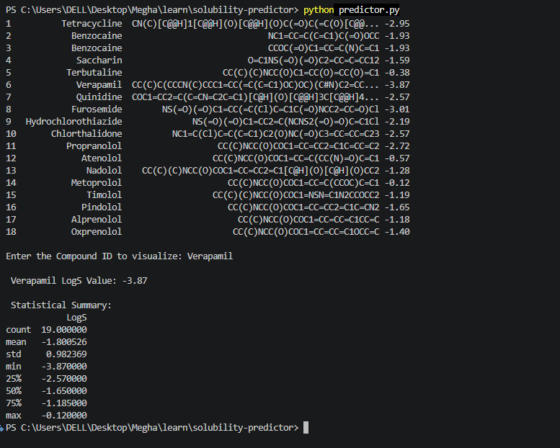

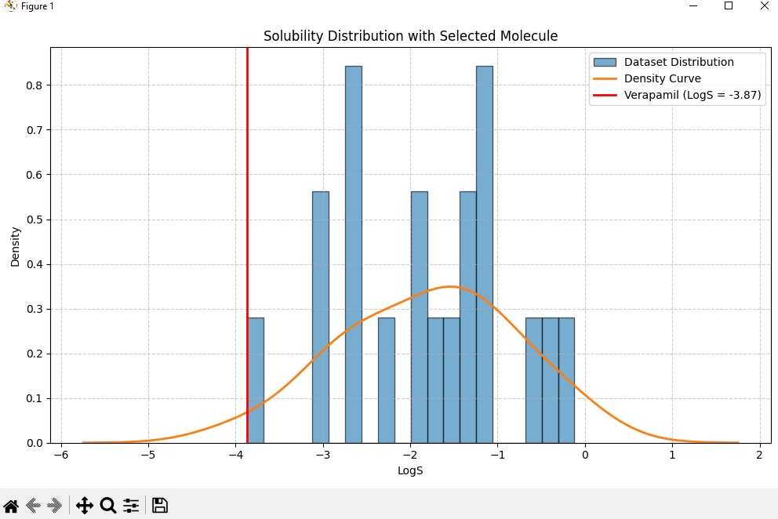

Applications
- 💊 Drug development (predict drug absorption)
- 🌱 Environmental analysis (pollutant solubility)
- 🧪 Chemical research and formulation
- 🏭 Industrial process optimization

Limitations
- Limited dataset size
- Prediction accuracy depends on training data quality
- Current code focuses mainly on data loading
- Requires integration of full ML model for prediction

Future Scope
- Implement full Random Forest model for prediction
- Integrate user input for real-time predictions
- Build a web interface (using Flask/Streamlit)
- Improve accuracy with larger datasets
- Add visualization of molecular structures

Conclusion
This project demonstrates a foundational step toward building a molecular solubility prediction system using computational methods. By leveraging data handling techniques and machine learning concepts, it provides a scalable and efficient alternative to traditional experimental approaches. With further enhancements, the system can become a powerful tool in scientific and industrial applications.

References
- Delaney ESOL Dataset
- Pandas Documentation
- RDKit Documentation
- Machine Learning Concepts

